Michael Smith Foundation for Health Research (MSFHR)
REACH Grant Knowledge Translation Topics:
Review of GSSO Settings – Acute and Tertiary Care
November 23rd, 2021

Discussion:

[Facilitator 1] – We are here today to discuss where gender, sex, and sexual orientation (GSSO) data should be collected and how it should be used in acute and tertiary care (ATC).

Our next Meeting is on December 14th. It will be a summary of the REACH project work that was done this year
Today’s meeting focuses on step five of our action plan: “Integrate and tailor GSSO data collection with organizational structures, policies, use cases and workflow processes.”

Acute care definition for this meeting is: “Hospital-based acute inpatient care is a key component of the continuum of health services in Canada. It provides necessary treatment for a disease or severe episode of illness for a short period of time. The goal is to discharge patients as soon as they are healthy and stable.”

We mean these terms broadly and a lot of places have large amount of overlap between different types of care.

Important to pay special attention to certain types of staff that are often not considered, such as kitchen, housekeeping, and maintenance staff. What information do we display to/for them?

[Facilitator 2] – Remember to add unit clerks, coordinators, medical/nursing assistants to slides on people involved in care delivery and who have access to patient information. We recognize unit clerks and medical assistants, but I wouldn’t put them down as a provider.

[Facilitator 1] – These people are often the first point of contact when people come to the unit. Switching over to an ATC generic workflow that I have developed from my professional experience (see below). This workflow is centered on the patient. My question to you is where certain data elements should fit in within this workflow.

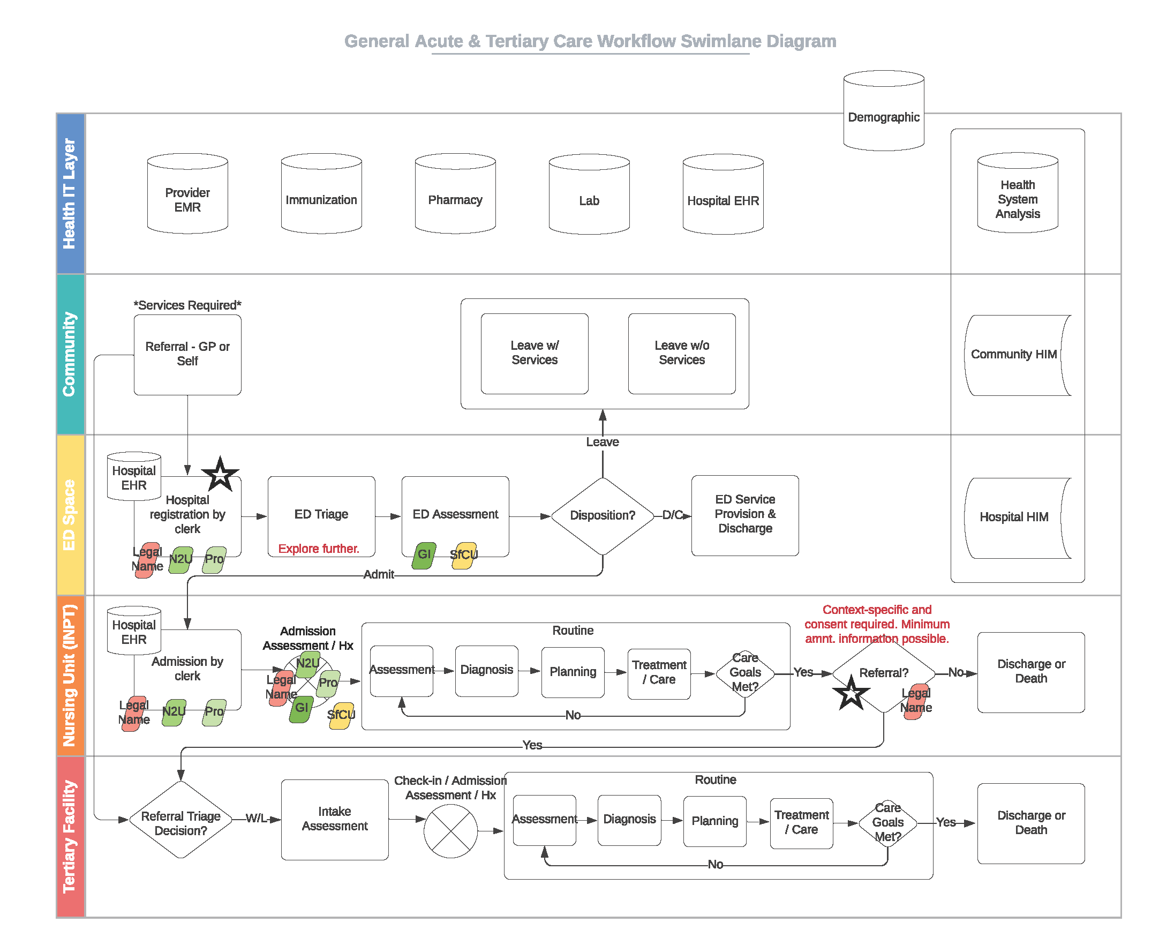

[2] – Patient identification happens at the first step of the various processes, at admission and registration.

[Facilitator 1] – What information ought to be collected at registration? To support downstream healthcare and communication.

[1] – Name to used and pronouns should be collected at the hospital registration.

[Facilitator 2] – Question about the difference between triage and assessment. Do you need gender identity (GI) for bed assignment in the emergency room (ER)?

[Facilitator 1] – Beds are usually assigned as the first bed that is available in the ER.

[2] – Yes, but when admitted to the hospital and a specific unit, you need to know gender identity for room or bed assignment.

[3] – Can you ask the question about the bed number again? What do you mean about beds in the ER?

[Facilitator 2] – I am unsure of how ER bed assignment work. Is it based on first available or is it segregated by gender?

[Facilitator 1] – Gender identity and sex for clinical use (SFCU) might come into the ER workflow.

[3] – I agree with [Facilitator 2], gender identity and pronouns must be collected because they do x-rays in the ER. I had a patient once that was misgendered by the person that was doing the ultrasound.

[Facilitator 1] – Moving on to further in the workflow. What does triage actually mean within Canada? It is done by a triage nurse and gender identity might be significant.

[2] – Why would gender identity be important for triage? Can you give an example?

[Facilitator 1] – I cannot think of one off the top of my head, but I have a gut feeling it is important for triage.

[Facilitator 1] – The assessment is done by complaint and the severity of the complaint; this determines how quickly you need to see a doctor. If its a high code Level 1, you get in immediately because you could die if you wait. Level 5 if not as severe. This determines how much time someone has to access information and they need to know certain things very very quickly. GI or SFCU might be big component of this type of care. I cannot think of any use cases off the top of my head, but I have a feeling that it might be important.

[Facilitator 2] – Lets mark this as something we need to explore more.

[Facilitator 1] – Sounds good to me.

[Facilitator 1] – This information flows throughout the patient’s journey in the hospital, like when they arrive in the unit. An initial assessment is done that usually very comprehensive.

[1] – I have a question for SFCU. Is this a single unit or multiple?

[Facilitator 1] – This comes from HL7’s gender harmony project (GHP). It has binary options and also a specified option, for things outside of the binary. For example, this person is a trans man who uses female reference ranges for lab tests.

[1] – In the scenario as someone as transitioning, they might have a one SCFU for imaging and another different for lab reference ranges.

[Facilitator 1] – SCFU can point towards other data elements such an anatomical inventory.

[2] – Specified from SCFU also used for cisgender folks. For example, if a cisgender women had a hysterotomy, her SCFU would be specified for imaging.

[Facilitator 2] – Is it specified just for the thing that ordered for, or can it change in different settings and different times?

[Facilitator 1] – Yes that is correct.

[Facilitator 2] – Thanks.

[Facilitator 1] – So at registration, GI would be in the person’s chart.

[4] – I am just trying to understand who in the workflow would be asking this info? Is it the registration clerks? Should they be collected clinical info?

[Facilitator 1] – I have never worked in a hospital where the clerk didn’t have training.

[4] – In my work, we engaged with the registration committee, and the question they had was “who are you putting in charge of collecting this info?” Had previous complexities when the Indigenous standards were pushed onto clerks, from patients asking, “Why are asking me this?”. This required a whole lot more of training for clerks. This had a large impact on their workflow.

[Facilitator 1] – We suggest putting it in place collection of GSSO to avoid deadnaming or misgendering in the hospital process.

[Facilitator 1] – How about referrals?

[2] – They would need patient contest on what to share. For labs, it would be name used, pronouns, and SCFU. For other referrals, it would be different information that need to be cleared by the patient to share.

[Facilitator 1] – How for other types of referrals, such as tertiary care for mental health? Should the hospital send information with the referral for the setting?

[1] – It is very context specific, based on different types of referrals. It needs the patient consent. What is the mini amount of info we could share automatically? – Personal Health Number (PHN)and legal name (or name to use). With pronouns and name to use, you have to check in with the patient first.

[Facilitator 1] – Consent is a huge factor, and I will add stars for places where it needs to be gathered from the patient.

[Facilitator 2] – We'll need to explore further how consent gets operationalized in care.

[Facilitator 2] – We need a lot bigger conversation about how we get consent, how is this standardized, and what healthcare professionals can do.

[1] - I agree, with some of the other data fields, these might be very useful but without the context for the specific referrals.

[4] – We are talking about acute care, patient comes in unconscious, how do we deal with this? How do we get accurate info to the physician?

[Facilitator 1] – We talked a bit about proxy in previous meeting. It comes down to safety, will the information help to save a life. Wrapping up, we are continuing this work in 2022.

