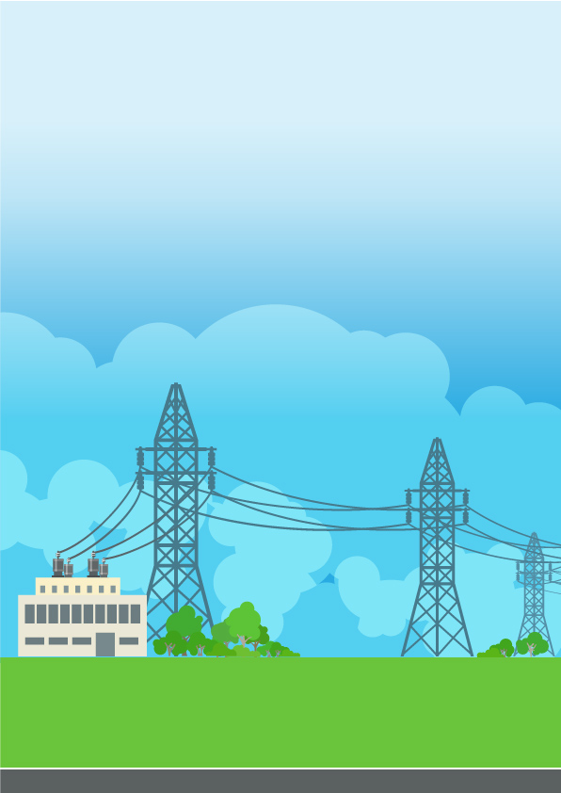
Subir Ghosh
Emp# 118868
Email: subir.ghosh@tcs.com
25/08/2025
DER Connections
- Challenges and Opportunities

Table of Contents
1. DER Connections – Centralised to de-centralised switch 2
2. ‘Energy Transition’ leading to accelerated DER Connection request 2
3. Major challenges with DER Connection 3
4. Facilitating accelerated DER connection 4
5. Digital capabilities to accelerate DER connections 5
6. Final thoughts 5

DER Connections – Centralised to de-centralised switch
The whole electricity market is undergoing fundamental transformation driven by De-carbonisation and De-centralisation, which is aligned with the “Net Zero” goals set by the Government and Electricity Market operators in different countries.
NOTE: Distributed Energy Resources (DERs) typically in the range of 3kW-50MW are connected in the Distribution Network. DERs are of multiple technology types e.g. wind, solar, gas, hydro, battery storage.
However, the mass deployment of the DERs is introducing major operational challenges for the Electricity System Operators (ESO), Transmission Network Operators (TNOs) and Distribution Network Operators (DNOs)/ Distribution System Operators (DSOs) for the planning & scheduling, real-time Balancing and maintaining the safety of the network, primarily due to lack of visibility & control of the DERs and reliant on weather dependent intermittent energy sources.
The traditional Electricity Grids wasn’t originally designed to connect the huge number of DERs – leading to a major backlog.

‘Energy Transition’ leading to accelerated DER Connection request
Success of the ‘Energy Transition’ and associated ‘Net Zero’ is dependent on 3 key factors:
- Transitioning from ‘Fossil Fuel’ to ‘Clean Energy’
- Customers adopting ‘Clean Energy’
- Enable faster Grid connection for ‘Clean Energy’ generators

UK and EU recording an unprecedented reduction in coal and gas power alongside a surge in renewable energy generation. In last 3 years Wind Generation in UK doubled from 7.1GW in 2021 to 14.2GW 2024 becoming main source of Britain’s electricity. By 2030 the North Sea Wind Farms alone could provide up to 120GW of offshore wind generation – enough to power over 120 million homes.

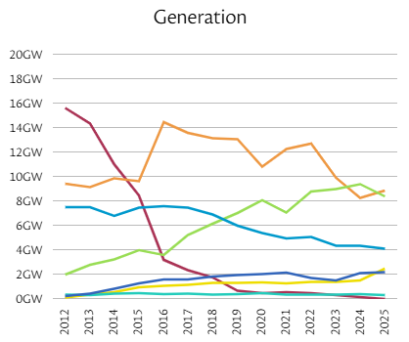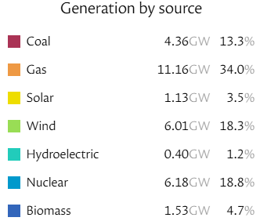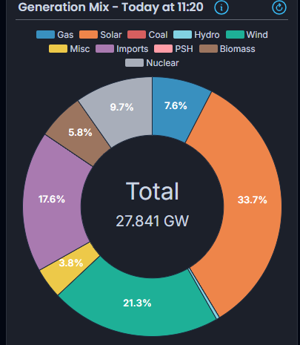
Long-term Generation trend

EU Electricity market having similar trend with Wind generation surpassing Gas for the first time in 2023. Fossil fuel experienced a 19% drop in 2023, while, wind and solar power collectively reaching a record 27% of EU electricity generation. Current forecast is renewable sources will account for 72% of EU’s power generation by 2030, an increase from 44% in 2023. This shift is primarily propelled by the expected doubling of wind and solar energy, from 27% in 2023 to 55% in 2030.

As the renewable energy is becoming more affordable, customers are embracing the ‘Clean Energy’. As technologies evolve customers are transitioning to energy prosumers who are producing, storing, trading and consuming electricity as per their demand - in a flexible, smart, convenient and affordable manner. As per European Renewable Energies Federation estimates there will be almost 24 million clean energy prosumers in the UK by 2050.

However, final piece of the jigsaw - enabling faster connection of the ‘Clean Energy’ generators in Grid is becoming the most challenging to overcome. The connection queue continues to grow resulting significant delays for new generators connecting in the grid, thereby slowing down the overall pace of the ‘Energy Transition’.

Major challenges with DER Connection
There are several factors which are impacting the rate of DER connections:

- Outdated Grid Infrastructure: Majority of the current Electricity Grid infrastructure in UK and Europe developed in last century was designed for one-way electricity flow from the large generators to the business, industries and household consumers. The high volume of DERs is creating constraints on the network capacity, voltage or reverse power flows. Moreover, current grid can’t provide the flexibility needed with the surge of de-centralised and intermittent DERs.

- Connection Approach leading to long queue: ‘First come, First served’ connection approach irrespective of the actual status of individual projects is leading to the formation of ‘queue’. Currently more than 600GW of generation in pipeline of connection applications.

- Network Constraints: Three categories of Network constraints are major challenges for faster DERs connections:
  - Transmission Constraints
  - Existing Distribution Constraints
  - Emerging Distribution Constraints

Network reinforcement to mitigate these Network constraints takes long time - between five to ten years, resulting DERs to wait up to a decade for grid connection.
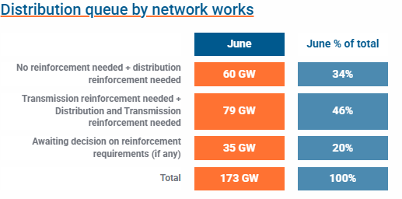

- Government Policy: In 2015 UK Government announced their intention to withdraw subsidy support for onshore wind farms which significantly slowed down the growth of the DER connection seen in early 2000s.

- Cost and Technical requirements for connection and ongoing operations: DERs connecting in the grid must invest heavily to fulfil various technical requirements for the safety, performance, operation, testing and maintenance of equipment.

Facilitating accelerated DER connection

Multi-prong approach is required to overcome these challenges to enable accelerated DER connection. Traditional approach of reinforcing the T&D network is the most obvious option. ‘Strategic Infrastructure’, part of National Grid Electricity Transmission (NGET), is aiming to deliver 17 major infrastructure projects as part of ‘Great Grid Upgrade’ across England & Wales to connect more clean, low-carbon and secure energy to homes and businesses. However, it is costly, time consuming and have impacts to our ecology and environments, especially in regions with national parks and conservation areas.

Here are some innovative approaches being progressed to enable accelerated DER connection.

- ‘Flexible Connection’ approach: DNOs are offering ‘Flexible Connections’ contracts to new DER connections in areas of network which require reinforcement. ‘Acceptance of the constraints’ is included in connection contract for ‘Flexible connections’ – generators agreeing to reduce their energy export under certain network conditions. Generators can avoid upfront expenses and time involved in reinforcing the network – thereby fast-tracking DER connections.

- Commercial services for DER market participation: System Operators are coming up with new commercial service and solutions for effectively manage the constraints and enabling DERs to connect. UKPN & NESO is aiming to accelerate the connection of over 1.5GW of generation and battery projects in next 10-15 years in South-East England, with known network constraints, by introducing the ‘RDP MegaWatt Dispatch’ service.

- Industry collaboration to limit the active power flow in GSPs: Grid Supply Point (GSP) Technical Limits is a NESO, TO & DNOs collaborative initiative aiming to accelerate the connection of generation and storage units into the distribution network ahead of the required transmission reinforcement works. MW Export and Import limits are pre-agreed for each GSPs with DNOs obliged to maintain these limits to enable DERs connections in those GSPs before the completion of transmission reinforcement works.

- ‘Connections Reform’ - Connections queue management and optimation: ‘Connections Reform’s long-term ambition is to create strategic and manageable connection process. “First ready and needed, first connected” approach is proposed from earlier “first ready, first connected” approach. Queue optimisation will also help to make the best use the network by prioritising the ‘ready to connect’ projects.

- Government Policy changes The new UK Government in July’2024 declared policies for abolishing the previous moratorium on onshore wind and committed to ‘doubling onshore wind energy by 2030′.

Digital capabilities to accelerate DER connections

Digital capabilities are going to be key enablers in whole Electricity T&D value chain to overcome the challenges high-lighted in previous section. These digital solutions will help to:
- Improve customers experience for new DER connections
- Provide DERs access to new and existing markets
- Maintain integrity and security of the T&D networks
- Operate efficient, economic and coordinated T&D networks
- Manage network constraints at least cost to consumers

Here are some of the key digital solutions ESO/DNO/DSOs are already implementing or planning to implement to facilitate fast-tracking DER connections.

- Connections platform: ESO/DNO/DSOs are aiming to improve overall customer experience for new connections and completely digitise the connection process utilising modernised Connections platform including self-service Connection Portal.

      - Flexibility Platform: ESO/DNO/DSOs are implementing Flexibility Platforms to automate the end-to-end procurement and management of flexibility services — from registration, qualification, dispatch to performance assessment and market settlement.

      - Active Network Management (ANM) solution: With growing connections in distributed network, ANM is going to play crucial role for DNOs/DSOs to manage real time output of distributed generation in constrained areas. ANM solution will enable DNOs/DSOs Control Room Engineers to effectively manage network thermal constraints, voltage constraints and fault levels.

      - Distributed Energy Resources Management System (DERMS): DERMS is an autonomous, software-based control system that monitors grid conditions and issues instructions to DERs to maintain the distribution network within its limits. DERMS will enable DNO/DSO Control Room Engineers to effectively manage the safety and security of the network and allow increasing volume of the DERs to connect.

TCS is collaborating with ESO/DNO/DSOs to implement these solutions and supported NESO to implement the ‘MegaWatt Dispatch’ and ‘GSP Technical Limits’ solutions to accelerate DER connection.

Final thoughts
With the current multi-year wait for Grid connection many developers will be turned off as they’re looking to get projects up and running quickly. While the new policy announcement by Government is a positive step forward, however, this will put more pressure on the Grid especially areas with T&D constraints. Hence new services like ‘MegaWatt Dispatch’ or ‘GSP Technical Limit’ along with the new-age Smart Grid solutions of DERMS/ANM and Flexibility Solutions will play a crucial role for effectively managing the safety and security of the T&D network. Along with these, improving the overall customer experience for new connections through modern connections platform can enable accelerated connection of DERs to facilitate the ‘Energy Transition’ and fulfil ‘Net Zero’ goal.



All content / information present here is the exclusive property of Tata Consultancy Services Limited (TCS). The content / information contained here is correct at the time of publishing. No material from here may be copied, modified, reproduced, republished, uploaded, transmitted, posted or distributed in any form without prior written permission from TCS. Unauthorised use of the content / information appearing here may violate copyright, trademark and other applicable laws, and could result in criminal or civil penalties. Copyright © 2021 Tata Consultancy Services Limited.
Contact
For more information, contact subir.ghosh@tcs.com

About Tata Consultancy Services (TCS)
Tata Consultancy Services is an IT services, consulting and business solutions organisation that delivers real results to global business, ensuring a level of certainty no other firm can match. TCS offers a consulting-led, integrated portfolio of IT and IT-enabled infrastructure, engineering and assurance services. This is delivered through its unique Global Network Delivery ModelTM, recognised as the benchmark of excellence in software development. A part of the Tata Group, India’s largest industrial conglomerate, TCS has a global footprint and is listed on the National Stock Exchange and Bombay Stock Exchange in India.
For more information, visit us at www.tcs.com.

Source: https://grid.iamkate.com/
Source: Live UK Electricity Generation, Carbon Intensity & Demand – Energy Dashboard
Source: ‘European Electricity Review’ report, for 2023
Source: https://www.energynetworks.org/industry/connecting-to-the-networks/connections-data

